Supplementary Examination [2023-24]
Class: IX [Science] Date: 28/02/2024 Time: 3 hrs MM: 80
General Instructions:
(a) There are 39 questions in this question paper with internal choice.
(b) SECTION A consists of 20Multiple - Choice Questions carrying 1 mark each.
(c) SECTION B consists of 6Short Answer Questions carrying 2 marks each.
(d) SECTION C consists of 7 Short Answer Questions carrying 3 marks each.
(e) SECTION D consists of 3Long Answer Questions carrying 5 marks each.
(f) SECTION E consists of 3 case - based questions carrying 4 marks each.
Section A
- Gases show the property of diffusion due to:
- High speed of particles and large space between them
- low speed of particles and less space between them
- Doesn’t have any space between them
- None of the above
- On increasing the temperature of solids:
- Kinetic energy of particles increases c) Kinetic energy of particles decreases
- Kinetic energy remains unchanged d) Kinetic energy can be decreases or increases
- Mass of solution contains 40g of NaCl in 320g of wateris:
- 360g b) 320g c) 40g d) 11.1g
- One atomic mass unit is a mass unit equal to:
- 1/12th the mass of one atom of carbon-12 c) 1/12ththe mass of one atom of carbon-14
- 1/12th the mass of one atom of hydrogen d) 1/12ththe mass of one atom of oxygen-16
- Positively charged atoms are called:
- Cations b) Anions c) Electrons d) Neutral
- The ratio by number of atoms for water is H:O=
- 2:1 b) 1:2 c) 1:1 d) 2:3
- Formula for calcium oxide:
- CaO b) Ca₂O c) CaO₂ d) Ca₂O₂
- For membrane biosynthesis which organelles coordinate
- Rough endoplasmic reticulum c) Smooth endoplasmic reticulum
- Golgi apparatus d) All the above.
- Girth of stem increases due to
- Apical Meristem b) Lateral Meristem c) Intercalary Meristem d) Vertical Meristem
- Growing two or more crops simultaneously in the same field without any order is
- Intercropping b) Mixed cropping c) Crop Rotation d) All the above.
- Which one is an indigenous breed of cow?
- Jersey b) Sahiwal c) Brown swiss d) Holstein friesian
- Increasing food production without compromising with environmental quality is called as
- Sustainable agriculture c) Sustainable development
- Hybridization d) Ecosystem services.
- If a moving body comes to rest, then it's acceleration is:
- Negative b) Positive c) Constant d) Zero
- A truck carries sand. Due to hole in the base of truck, significant amount of sand falls continuously. For the same condition of working of the engine, the speed of the truck should
a) increase b) cannot be found c) remain the same d) decrease
- S.I. unit of power is
  - J/s b) s/J c) Js d) Js²
- In the bell jar experiment, as air is removed
  - elasticity falls c) intensity falls
  - speed of sound falls d) both intensity falls and speed of sound falls
- Assertion (A):Fluorine has one valency with atomic no. 9.
Reason (R): The number of electrons gained, lost or shared so as to make the octet of electrons in the outermost shell called valency.
  - Both A and R are true and R is the correct explanation of A.
  - Both A and R are true but R is not the correct explanation of A.
  - A is true and R is false.
  - A is false and R is true.
- Assertion (A):Chromosomes carry information about inheritance of characters.
Reason (R): Chromosomes are only visible at the time of cell division
- Both A and R are true and R is the correct explanation of A.
- Both A and R are true but R is not the correct explanation of A.
- A is true and R is false.
- A is false and R is true.
- Assertion (A):Skeletal muscles are striated
Reason (R): Smooth muscles are involuntary in nature.
- Both A and R are true and R is the correct explanation of A.
- Both A and R are true but R is not the correct explanation of A.
- A is true and R is false.
- A is false and R is true.
- Assertion (A): Any two objects in the universe attract each other by a force called gravitation force.
Reason (R): The force of gravitation exerted by the earth is called gravity.
- Both A and R are true and R is the correctexplanation of A.
- Both A and R are true but R is not thecorrect explanation of A.
- A is true and R is false.
- A is false and R is true.
Section B
Short Answer Type Questions I: ( 2 Mark Each)
- Write the electronic distribution in various shells of Nitrogen(N) and Chlorine (Cl).
OR
Explain isotopes with an example.
- Where are proteins synthesized in cell?
- Name the following: -
  - Tissue that transport food in plant.
  - Tissue that connects muscle to bone in humans.
OR
State two important functions of Areolar tissue.
- Why does a cricket player move his hands backward while catching the ball?
- A body is moving with a uniform velocity of 10 ms-1. Find its velocity after 10 s?
OR
Distinguish between terms speed and velocity.
- What management practices are common in dairy and poultry farming?
Section C
Short Answer Type Questions II: ( 3 Mark Each )
- Explain:
- Sublimation
- Evaporation
- Latent Heat
- Explain Thomson’s model of an atom with its limitations.
- a) Which cell organelle will you associate with ATP production? How is this organelle able to make its own protein?
- A student performed an experiment by placing a deshelled egg in a concentrated salt solution for 5 minutes. What change did he observe in the egg? Give reason for the same.
- The speed-time graph of a car is given. The car weighs 1000 kg.
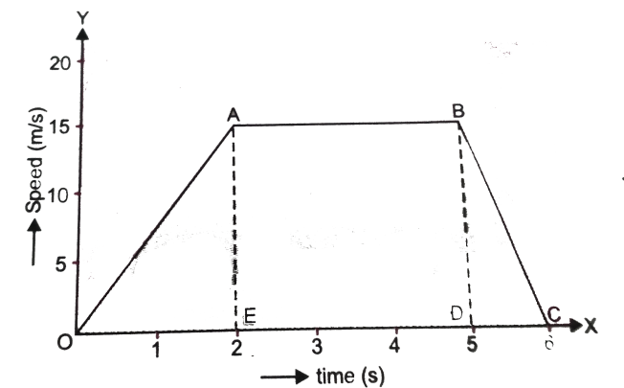

- What is the distance travelled by car in the first 2s?
- What is the braking force applied at the end of 5 s to bring the car to stop within one second?
- The position of a body at different times is recorded in the table given below:-
Time (s) | 0 | 1 | 2 | 3 | 4 | 5 | 6 | 7 | 8
Displacement (m) | 0 | 6 | 12 | 18 | 24 | 30 | 36 | 42 | 48

    - Draw the displacement time graph for the above data.
    - What is the slope of graph?
    - What is the velocity of the car?
- In each of the following, a force F is acting on an object of mass m. The direction of displacement is from West to east shown by the longer arrow. Observe the figure carefully and state whether the work done by the force is negative, positive or zero.

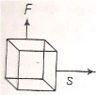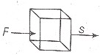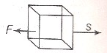

OR
Prachi and Kanchi were observing a building having two different staircase. One slanting and other vertically spiral. Prachi was of the opinion that a person using slanting staircase will be doing more work against gravity but Kanchi thought otherwise. They started arguing. Sanchi, their friend, explained and gave entirely different view and specified them:
- What according to you was the explanation given by Sanchi?
- What appreciable values do you see in the Sanchi?
- What is Workdone. Write its SI Unit.
- Describe the structure and function of epithelial tissues. Also draw well labeled diagrams.
Section D
Long Answer Type Questions (5 Mark Each)
- Calculate the molar mass of the following substances:
[Atomic masses of C = 12𝓊, O = 16𝓊, Cl = 35.5𝓊, Ca = 40𝓊, Na = 23𝓊, N = 14𝓊, H = 1𝓊]
- C₂H₂ b) HCl c) HNO₃ d) Ca(OH)₂ e) Na₂CO₃
OR
  - Define law of conservation of mass with an example.
  - Write down the chemical formulae of following compounds: Calcium oxide, Magnesium chloride, Calcium carbonate
- a) Draw well labeled diagram of plant cell.
- How it is different from animal cell.
- Define frequency and wavelength with reference to sound. Explain, what is echo? Write full form of SONAR. Give two applications of ultrasound.
Section E
Case based questions (4 mark each)
- A homogeneous mixture of two or more substances is called a true solution. it consists of solute and solvent. The particle size of the true solution is less than 1 nanometer. A suspension is a heterogeneous mixture in which the solute particle does not dissolve but remains suspended throughout the bulk of the medium. A colloid is a mixture that is actually heterogeneous but appears to be homogeneous as the particles are uniformly spread throughout the solution.
- Which one of the following is most stable?
- True solution b) Suspensions c) Colloids d) both A and B
- Which type of mixture can be separated by filtration?
- True Solutions b) Suspensions c) Colloids d) All of these
- Which statement is incorrect about the Tyndall effect. *
- True solution shows Tyndall effect
- Suspensions show the Tyndall effect
- Colloid show Tyndall effect
- Both B and C show the Tyndall effect
- Which is the correct order of stability of solution *
- True < Colloid<Suspension c) Colloid<Suspension<True
- Colloid<True<Suspension d) Suspension<Colloid<True
- Poultry farming is undertaken to raise domestic fowl for egg production and chicken meat. Improved poultry breeds are developed and farmed to produce layers for eggs and broilers for meat. The cross-breeding programmes between Indian (indigenous, for example, Aseel) and foreign (exotic, for example, Leghorn) breeds for variety improvement are focused on to develop new varieties for the following desirable traits— number and quality of chicks; dwarf broiler parent for commercial chick production; summer adaptation capacity/ tolerance to high temperature; low maintenance requirements; reduction in the size of the egg-laying bird with ability to utilize more fibrous cheaper diets formulated using agricultural by-products.Broiler chickens are fed with vitamin-rich supplementary feed for good growth rate and better feed efficiency. Care is taken to avoid mortality and to maintain feathering and carcass quality. They are produced as broilers and sent to market for meat purposes. For good production of poultry birds, good management practices are important. The housing, nutritional and environmental requirements of broilers are somewhat different from those of egg layers. The daily food requirement for broilers is protein rich with adequate fat. The level of vitamins A and K is kept high in the poultry feeds. Poultry fowl suffer from a number of diseases caused by virus, bacteria, fungi, parasites, as well as from nutritional deficiencies. Appropriate vaccination can prevent the occurrence of infectious diseases and reduce loss of poultry during an outbreak of disease.
    - Identify the incorrect statements
Statement 1 – Broiler chickens are fed with vitamin-rich supplementary feed for good growth.
Statement 2 – The level of vitamins A and K is kept high in the poultry feeds
Statement 3 – The level of vitamins A and K is kept low in the poultry feeds
Statement 4 – Improved poultry breeds are developed and farmed to produce layers for eggs and broilers for meat.
  - Both 1 & 2 b. Only 2 c. Only 3 d. None of the above
    - Poultry breeds which are produce for eggs are termed as _________
  - Layers b. Broilers c. Indigenous d. Exotic
    - Poultry breeds which are produce for meat are termed as _________
  - Layers b. Broiler c. Indigenous d. Exotic
    - What are the objectives of cross-breeding programmes in Indian and Exotic breed?
- Every object in the universe attracts every other object with a force which is proportional to the product of their masses (M₁*M₂) and inversely proportional to the square of the distance (d²) between them. This force acts along the line joining the centres of two objects.
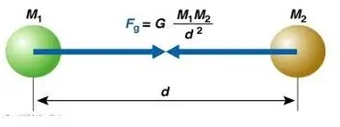

F = G $\frac{\left(M_{1}*M_{2}\right)}{d^{2}}$
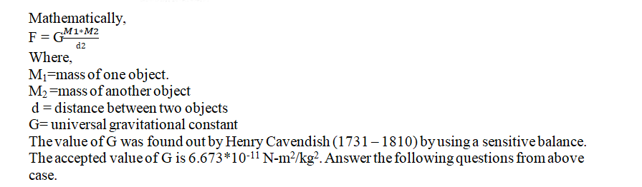

- Gravitational force does not depend on
  - Masses of objects c. Separation between objects
  - Charges on objects d. None of these
- Force of gravitation varies with masses of object as
  - Product of masses b. Sum of masses c. Difference of masses d. None of these
- When mass of one body is doubled then force of gravitation will become
  - Force will remain same c. Force will become double
  - Force will become halved d. None of these
- What is universal gravitational constant? What is its SI unit?

